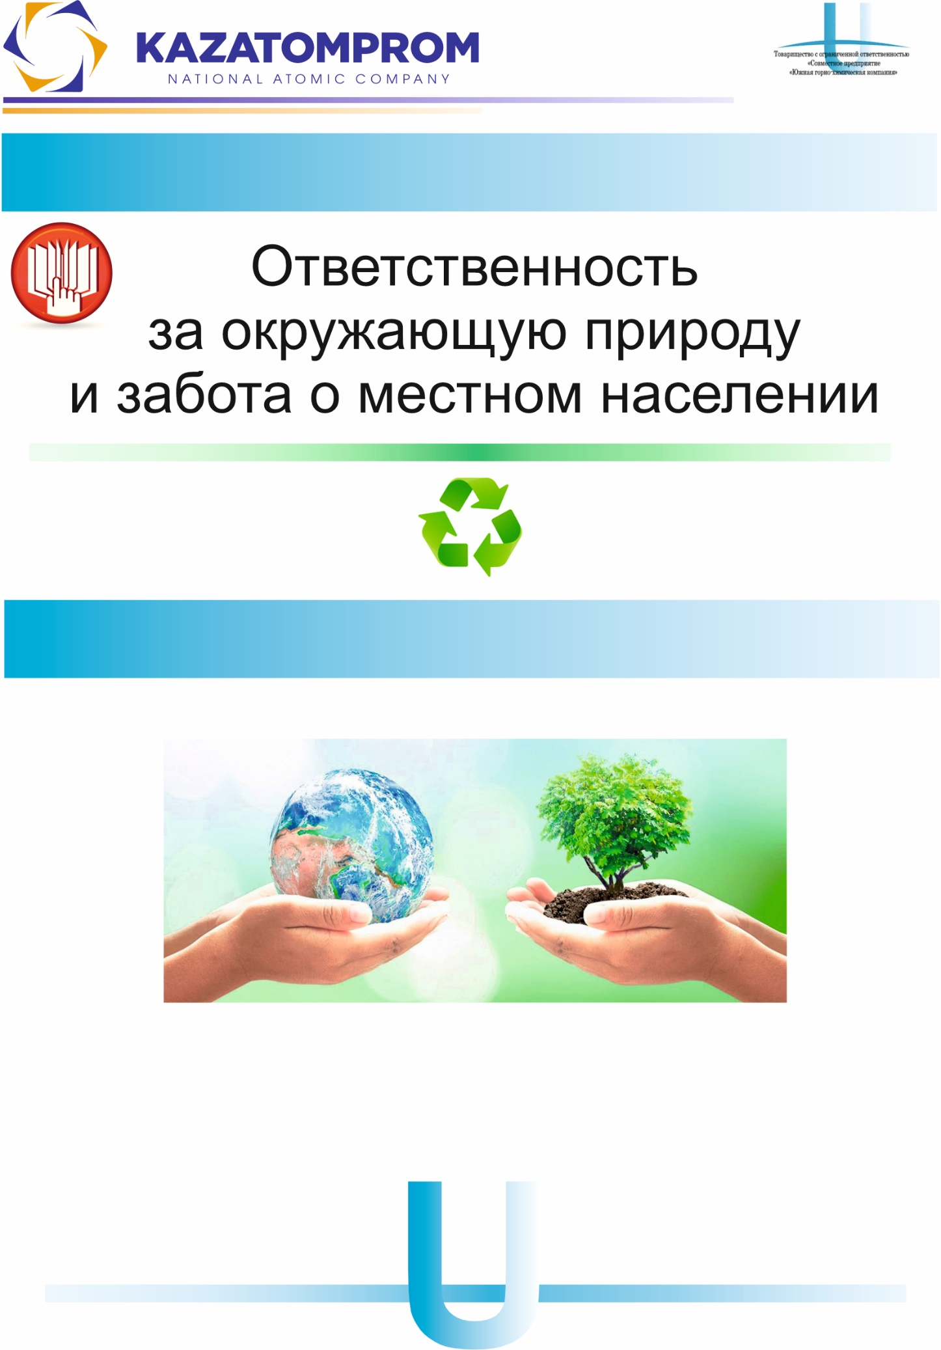

Responsibility for the environment and care for the local population

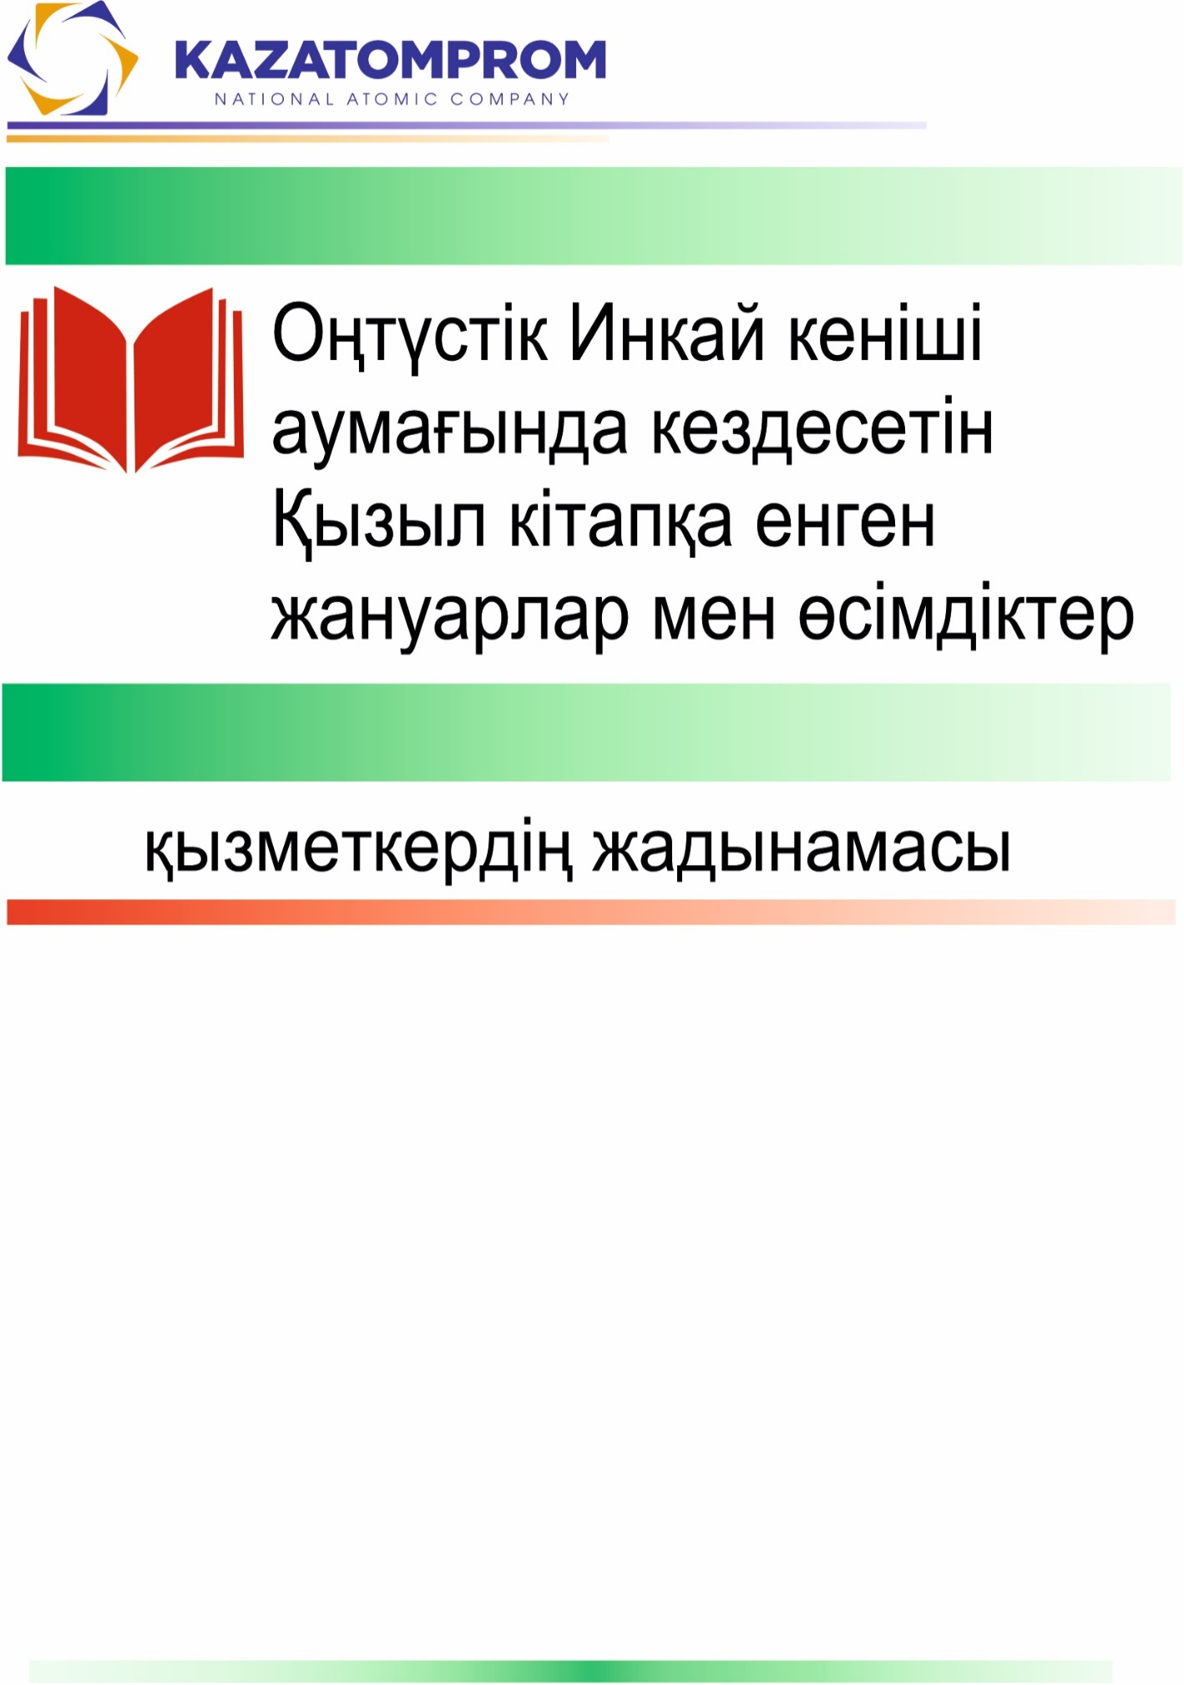

Responsibility for the environment and care for the local population

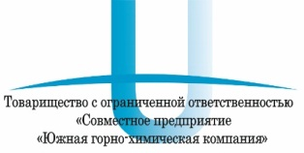

Almaty 2024

The Republic of Kazakhstan holds the second-largest uranium reserves in the world, following Australia.
«NAC «Kazatomprom» JSC is the national operator of the Republic of Kazakhstan for uranium mining and processing.
Since 2009, Kazakhstan has been the world leader in natural uranium production.
"NAC Kazatomprom" JSC includes 13 uranium mining enterprises, with their mines located in the Kyzylorda, Turkistan, and Akmola oblasts.

«JV «South Mining Chemical Company» LLP (SMCC)

The uranium mining enterprise "JV «South Mining Chemical Company" LLP was established in August 2014 for the purpose of exploration and uranium extraction at the Akdala and Yuzhny Inkai deposits.
The Akdala deposit is located in the Suzak Region of Turkistan Oblast, while the Yuzhny Inkai deposit lies on the border of Suzak Region (Turkistan Oblast) and Shieli Region (Kyzylorda Oblast).
This area is affected by the Aral Sea crisis, which is associated with the drying of the sea and the wind-driven spread of salt and dust over long distances.
Uranium extraction at the deposits is carried out using the in-situ leaching (ISL) method.

In-situ leaching is considered the most environmentally friendly and safest method for mineral extraction.

At the geotechnological site of the «Akdala» and “Yuzny Inkai» deposits, drilling operations are carried out to construct production, injection, and monitoring wells. As sulfuric acid solutions pass through the ore-bearing horizon, they react with uranium minerals, leaching the uranium by converting it into a soluble form.
The pregnant solutions from the production wells are brought to the surface using submersible borehole pumps and delivered to the Pregnant Solution Reception Unit (PSRU), from where they are transported via a pipeline manifold to the pregnant solution settling tanks located at the mine’s industrial sites.
The clarified solutions from the settling tanks are then pumped by the central pumping station to the sorption section of the solution processing plant.
The final product at the «Akdala» deposit is commercial-grade desorbate. The final product at the «Yuzny Inkai» deposit is uranium oxide concentrate.

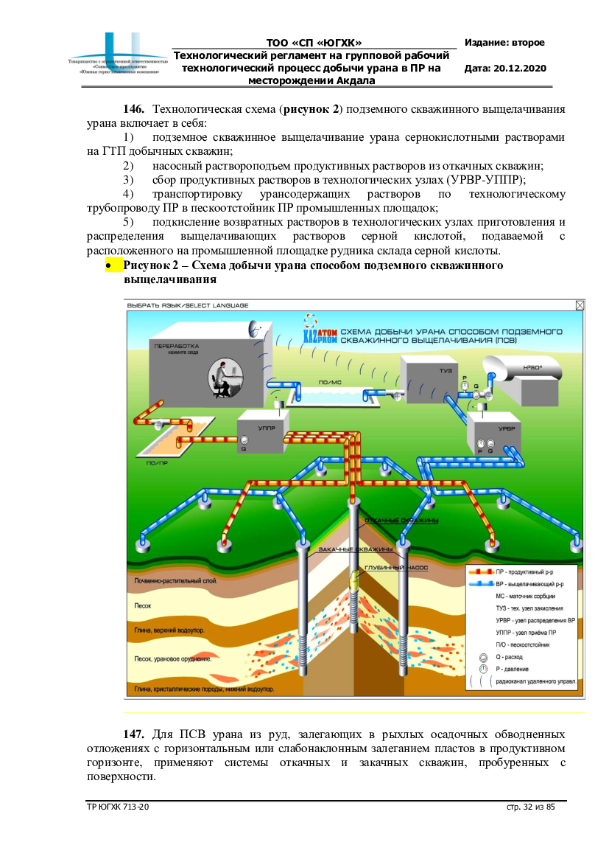

To prevent the release of solutions into the environment, injection and production wells are constructed using acid-resistant materials. All process solutions operate within a closed-loop circulation system, with no discharges into the environment.

All pipelines are located underground, with only the wellheads extending above the surface. The mine site is marked with informational and warning signs.

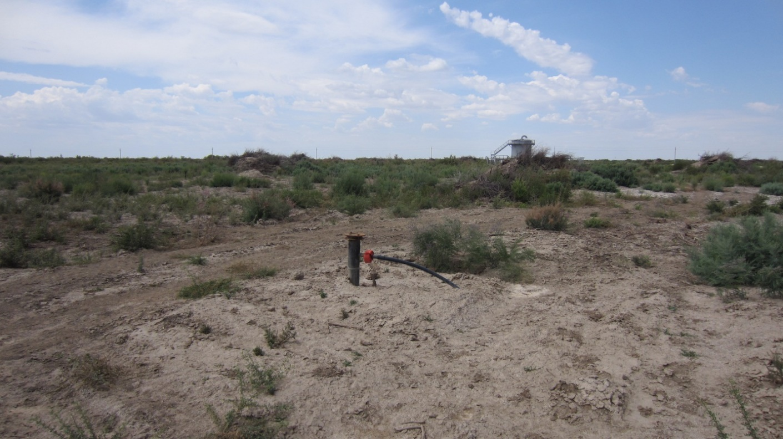

The “Akdala” and “Yuzny Inkai” mines are classified
as hazardous industrial facilities.

The local population is strictly prohibited from entering the production areas or allowing livestock to graze on the mine site.

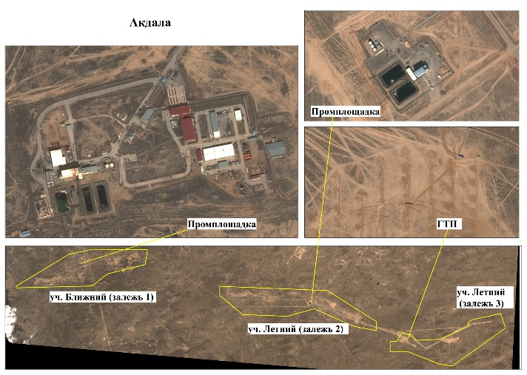
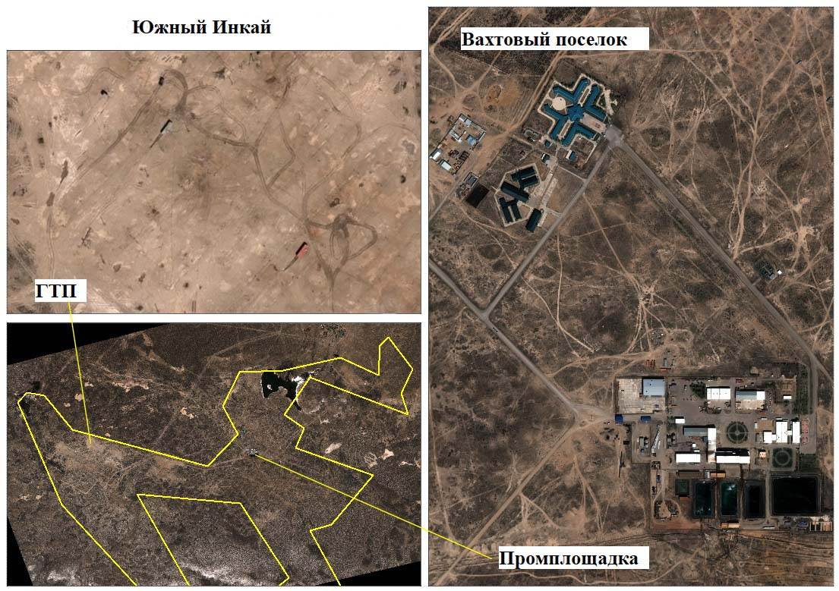
Uranium and process solutions are radioactive and toxic; their entry into the human body can cause poisoning.
However, uranium is a naturally occurring (background) element and is present in very small amounts everywhere — in water, soil, air, and plants.
Low concentrations of uranium do not harm the human body.
Mine personnel are reliably protected during work through the use of personal protective equipment.
Throughout the entire history of the in-situ leaching (ISL) mines, there has not been a single recorded case of uranium exposure exceeding permissible dose limits among workers!
Kazhydromet conducts monthly radiation level measurements in the air.

The safe natural background radiation level for humans is 20 µR/h (0.2 µSv/h).

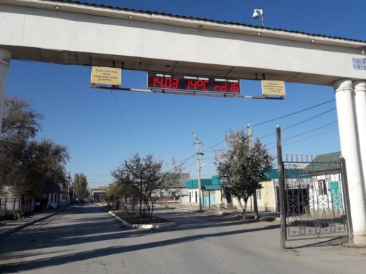

The average air radiation background levels in the settlements of the Turkistan oblast range from 0.01 to 0.31 µSv/h, with an average of 0.11 µSv/h.

Overall, the radiation situation in the Turkistan oblast remains within acceptable limits and complies with hygienic standards and regulations.

Atmospheric Air

The main sources of air pollution in the Turkistan oblast are cotton processing plants, oil pumping facilities, natural gas transportation enterprises, heat-generating boiler plants, and motor vehicles.
The contribution of enterprises belonging to «NAC «Kazatomprom» JSC to the total air pollution in the Republic of Kazakhstan is 0.076%.

There have been no recorded cases of high or extremely high levels of atmospheric air pollution in the Turkistan oblast.

Water Resources

The Turkistan oblast is home to 118 small rivers with a total length of over 2,200 km, 25 lakes, and 30 reservoirs.
The major river of the region is the Syr Darya (total length: 2,219 km, with 1,400 km within Kazakhstan), along with its tributaries—Kurkeles, Keles, Arys, Bugun, and other smaller rivers flowing from the southern slopes of the Karatau Range, as well as the Shu River. There are many small, mostly saline lakes, with the largest being Akzhaikyn, Akzhar, Kaldykol, among others.
According to the Unified Classification, the water quality in the Turkistan region is assessed as follows: Class 1 (very clean): Aksu and Bugun Rivers; Class 3 (polluted): Badam and Arys Rivers; Class 4 (dirty): Syr Darya, Keles Rivers, and Shardara Reservoir; Class 5 (very dirty): Katta Bugun River.

Land Resources

The largest portion of the land fund in the Turkistan oblast is made up of reserve lands (unused land), forest fund lands, and agricultural lands.

*Data taken from the National Report on the State of the Environment and the Use of Natural Resources of the Republic of Kazakhstan for 2022.

Hygiene standards
Water for household purposes and drinking:
salts up to 1 g /l,
acidity 6-9 units.
radioactive background (alpha activity + beta activity) 1.1 Bq/l
Natural waters

surface (rivers, channels, lakes)

underground (wells, boreholes)

the composition of natural waters is very diverse

there are no standards for them

Soil

Radioactivity according to sanitary standards is up to 1200 Bq/kg.

The salt content, favorable for agriculture, is up to 6 g/kg.

The acidity is at least 6 units.

Environmental Research

In 2022–2024, comprehensive environmental studies were conducted at the “Yuzhny Inkai” mine, including the analysis of water and soil samples, as well as assessments of biodiversity conditions in the following areas:
- within the mine territory;
- in nearby farming households;
- in wintering sites;
- in wells and boreholes;
- in the settlements of Kyzemshek and Taikonyr;
- at background points located more than 10 km from the enterprise boundaries.

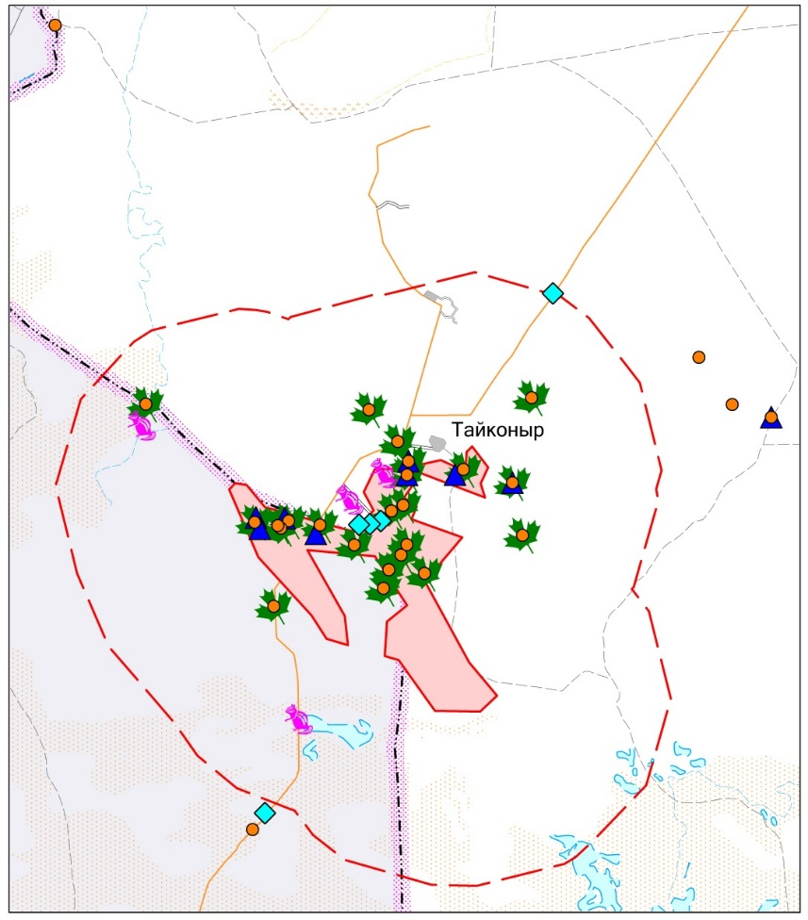

MAP SYMBOLS

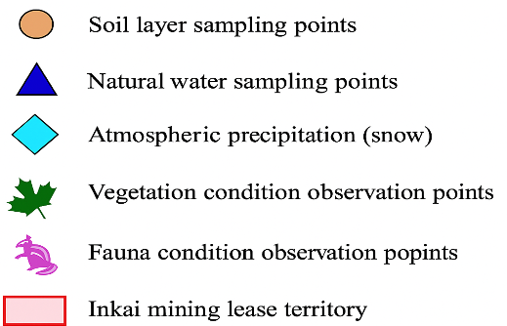

Results

The natural (background) values for natural groundwater in the study area have been determined:

- salt 0.6-1.0 g/l,
- acidity 8,0-8,3 units.
- radiation 0.3-0.9 Bq/l

It is not recommended to use water from shallow water sources in wintering grounds and on farms for drinking purposes without prior preparation (filtration).

For economic purposes, it is necessary to drill wells to a great depth (100-150 m) and conduct a complete chemical analysis of the water before using it.

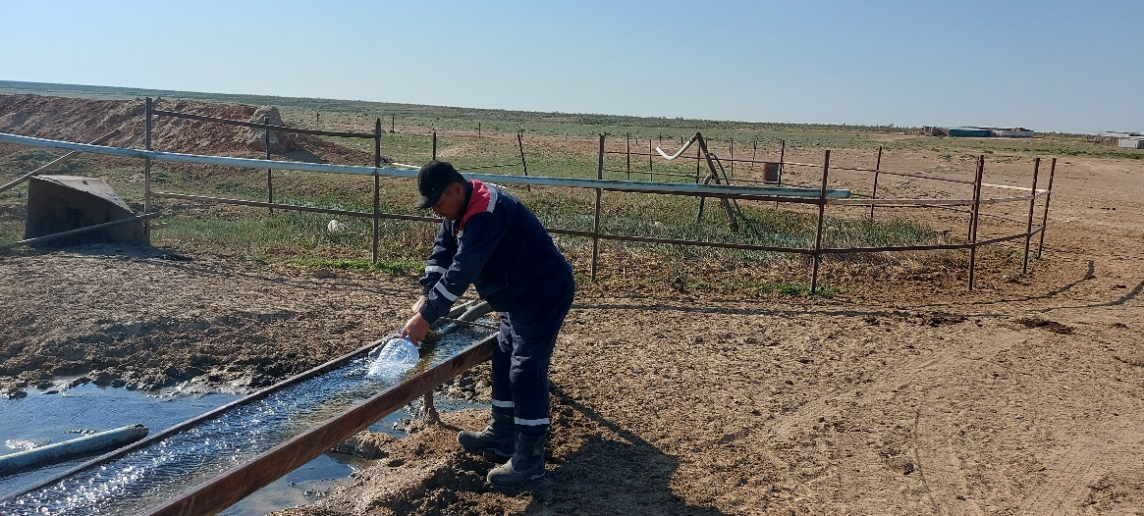

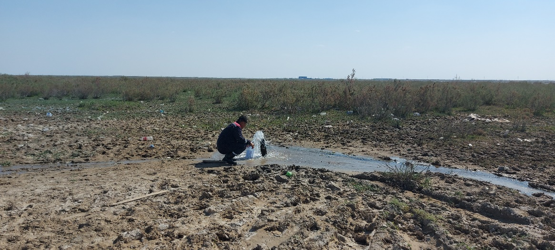

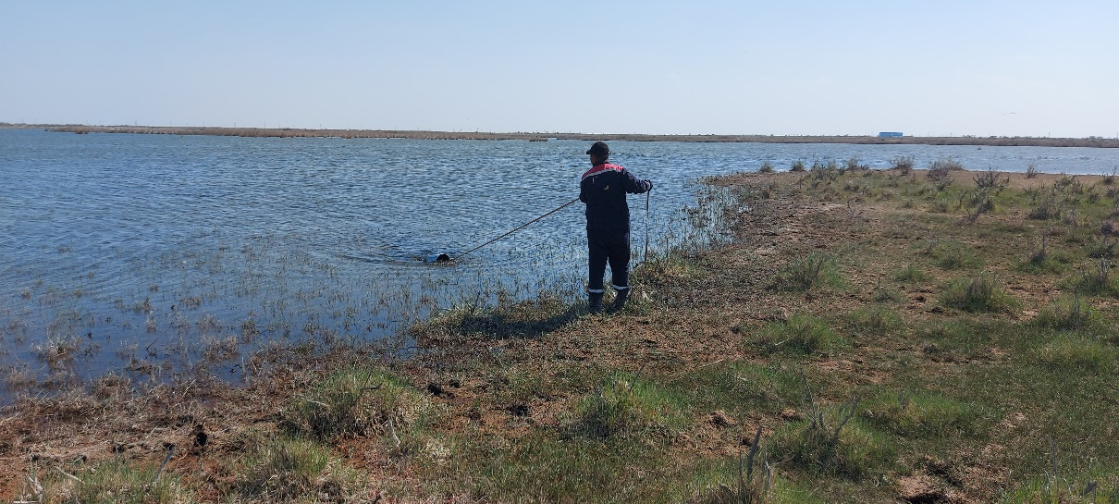

The natural (background) values for the soil in the studied area have been determined:
- salt content 2-8 g/kg,
- the radioactive background is 260-680 Bq/kg.
- acidity 8-9 units.
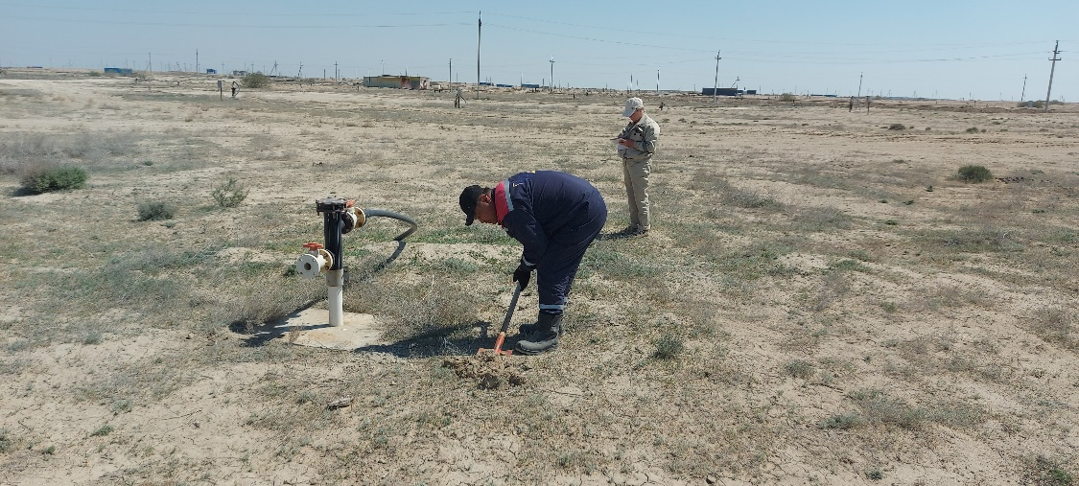

No man-made pollution has been detected outside the production facilities of the «Yuzhny Inkai» mine. All indicators correspond to natural values.

Assessment of the state of biodiversity

Vegetation cover. During the survey of the territory adjacent to the Southern Inkai mine, 75 plant species were recorded. .
Black saxaul (leafless) is valued as a fuel, fodder and technical plant.
No rare, endangered or endemic plants have been identified in the area of the Southern Inkai mine.

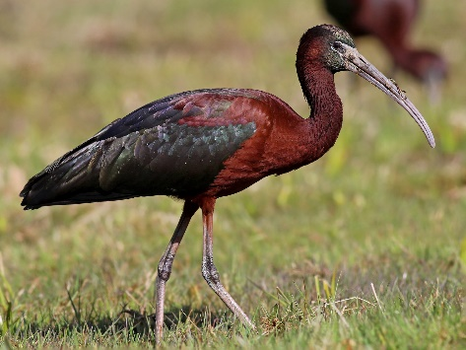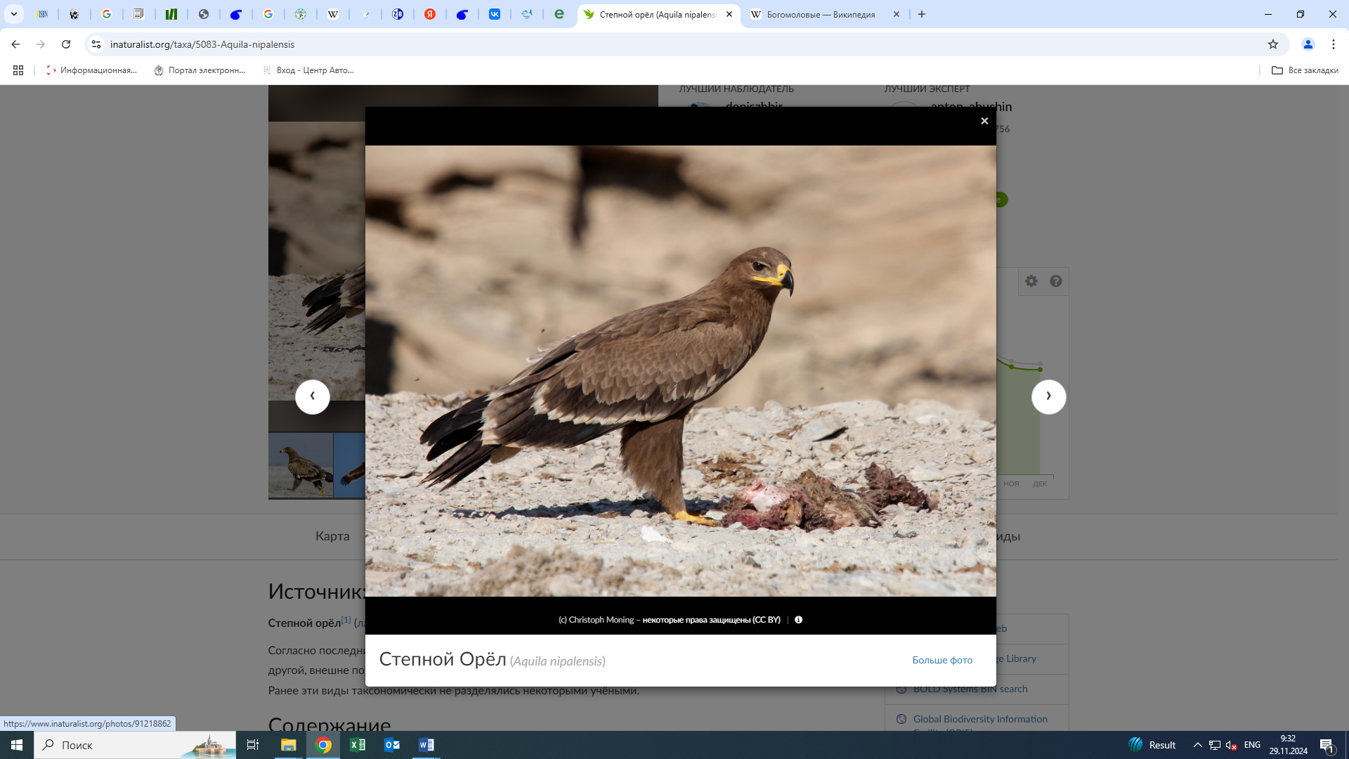
Glossy Ibis (Plegadis falcinellus) Steppe Eagle (Aquila nipalensis)

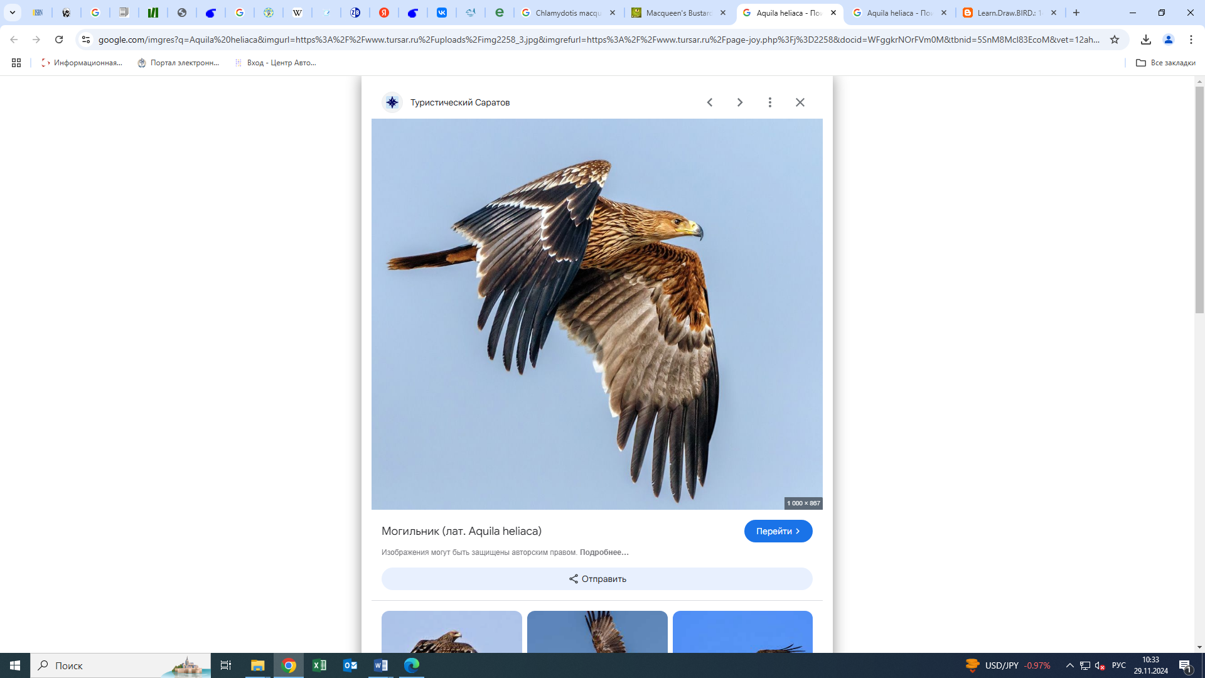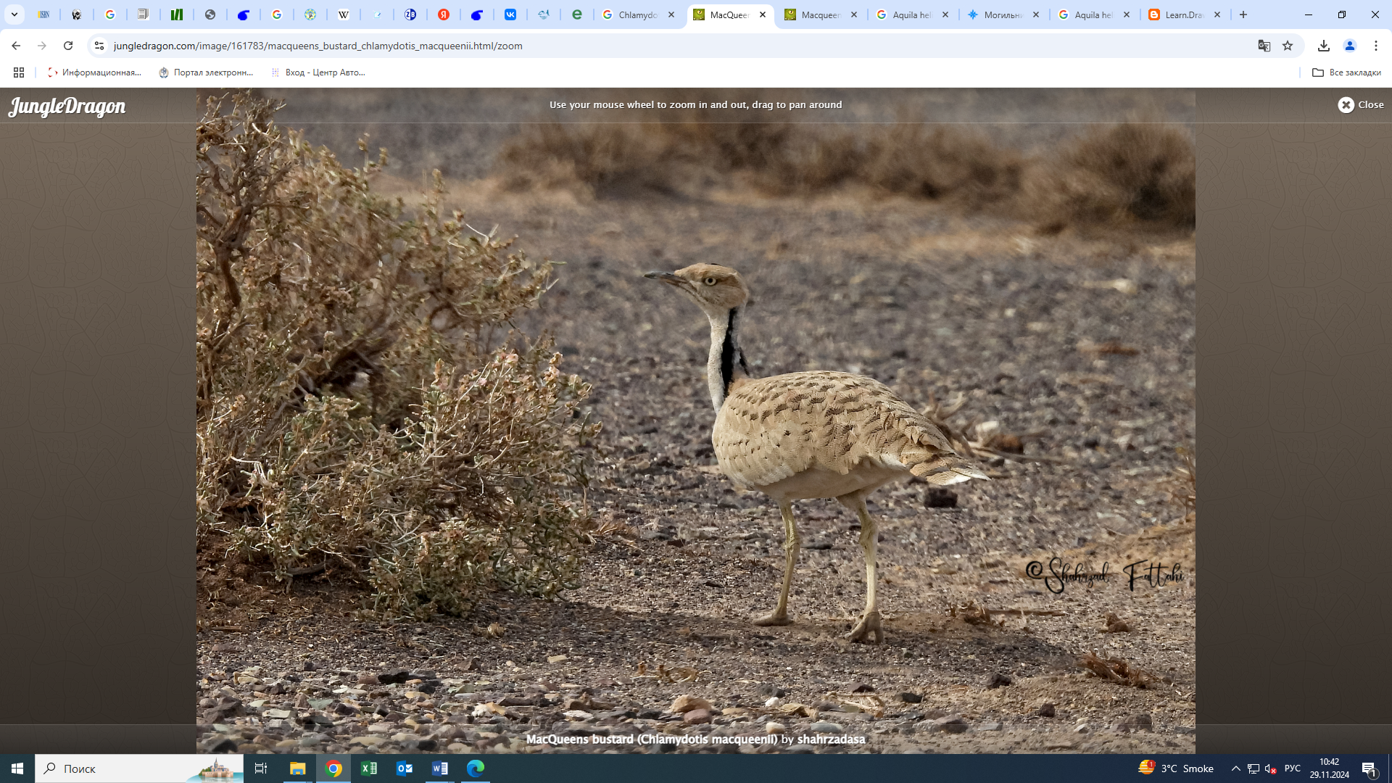
Imperial Eagle (Aquila heliaca) Lesser Florican (Chlamydotis macqueenii)

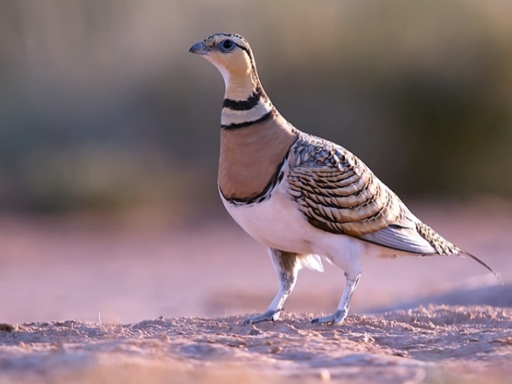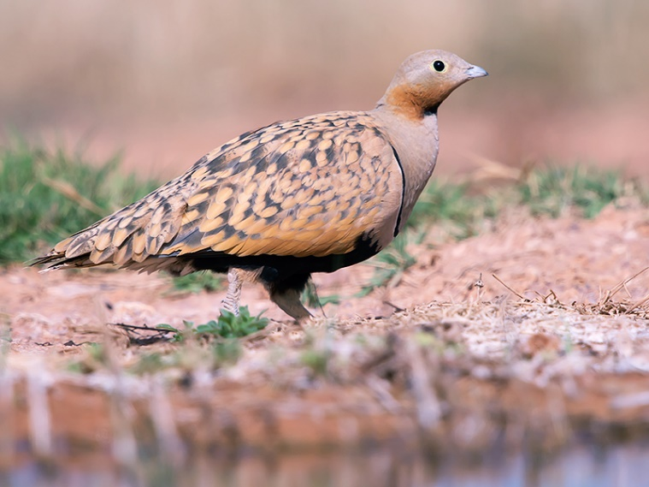
Pallas's Sandgrouse (Pterocles alchata) Black-bellied Sandgrouse (Pterocles orientalis)

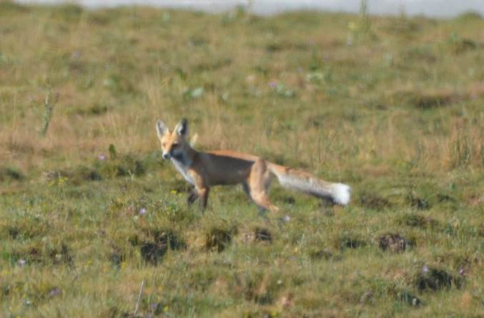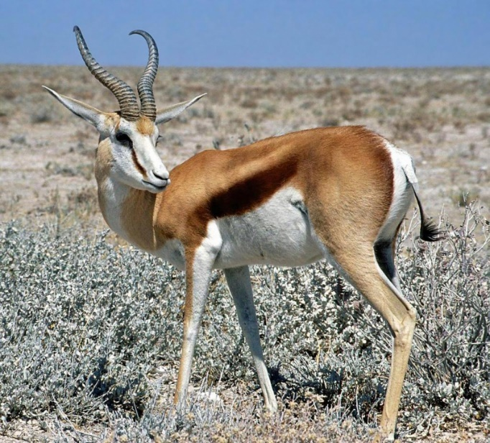
Corsac Fox (Vulpes corsac) Goitered Gazelle (Gazella subgutturosa)

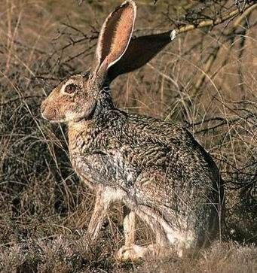
Tolai Hare (Lepus tolai) Selevinia (or Desert Dormouse) (Selevinia betpakdalaensis)

Wildlife. Up to 36 species of mammals, 88 species of birds, 2 species of amphibians, and 16 species of reptiles inhabit the area surrounding the South Inkai mine. Among them, four mammal species listed in the Red Book of Kazakhstan are considered rare: the goitered gazelle (dzheiran), marbled polecat, steppe polecat, and Selevinia (desert dormouse). Nine bird species are also listed in the Red Book: the imperial eagle, steppe eagle, pin-tailed sandgrouse, black-bellied sandgrouse, houbara bustard (also known as "jack"), MacQueen’s bustard (saga), glossy ibis, saker falcon, and little bustard.
The Central Asian tortoise (Testudo horsfieldii) is listed in the International Red List (IUCN) as a vulnerable species.
Background (common) rodent species include: the great gerbil, red-tailed gerbil, yellow ground squirrel, and small jerboa. Among predators: corsac fox, steppe ferret, red fox, badger, and Pallas's cat. Among lagomorphs: Tolai hare. Among insectivores: long-eared hedgehog.
Typical background bird species include: desert wheatear, finch's wheatear, desert warbler, rusty-winged finch, tawny bunting, desert shrike, crested lark, lesser short-toed lark, and long-legged buzzard.
In the tree plantations around the shift camp and office of the South Inkai mine, synanthropic and dendrophilous birds are common: rock pigeons, house sparrows, flycatchers, chiffchaffs, warblers, orioles, wagtails, common mynas, and Eurasian collared doves.
Six species of reptiles and amphibians have been recorded: steppe-runner lizard, rapid racerunner, striped racerunner, steppe agama, arrow snake, and green toad.

No impact of the company’s activities on wildlife has been identified!

«JV «SMCC» LLP will continue to regularly monitor the state of the natural environment at the mine and in the surrounding areas, and will promptly take action to protect nature. Special attention will be given to the preservation of plant and animal life.

Social Research

«JV «SMCC» LLP participates annually in charitable initiatives — providing assistance to orphanages and large families, building social infrastructure, and supporting youth.
From 2021 to 2024, charitable aid was provided to orphans, single mothers, recipients of the “Altyn Alqa” and “Kumis Alqa” medals, and low-income families in the village of Kyzemshek.
Additionally, support was given to T. Mombekov Secondary School in the village of Taikonyr for the installation of an irrigation system to prepare the schoolyard for landscaping and greening, among other activities — totaling more than 30 million tenge.
The company also funded university education for 112 students from socially vulnerable families in the Suzak district.
In 2024, social research was conducted, including two focus groups (one in Taikonyr village with 9 participants and one in Kyzemshek village with 11 participants) and 6 interviews. A total of 8 meetings were held, surveying 26 participants.
During the meetings, participants discussed quality of life, socio-economic conditions, agricultural development, livestock grazing conditions, problematic issues and possible solutions, and their attitude toward the operational activities of «JV «SMCC» LLP. Survey participants assessed the company's engagement with stakeholders and the local community. Topics also included plans and approaches for the final decommissioning of the mine after uranium extraction is completed.

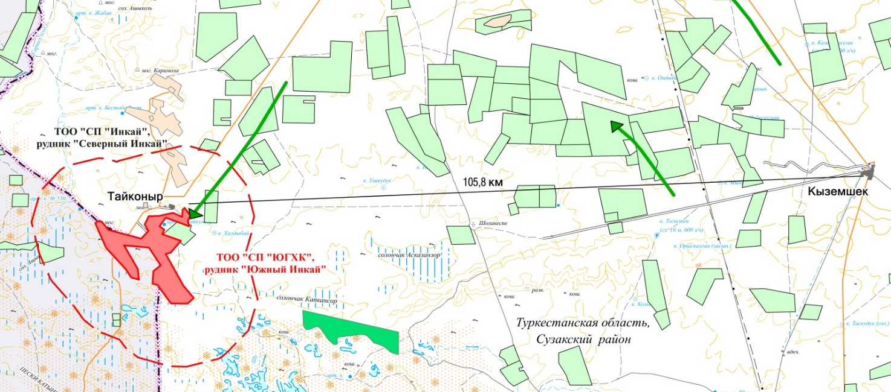

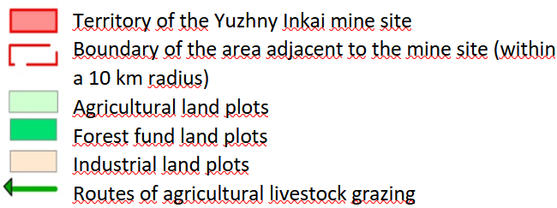

On the territory adjacent to the production facilities of the «Yuzhny Inkai» mine, the mining allotment sites of the «Severny Inkai» mine («JV «Inkai» LLP) are located to the north, agricultural land is located to the northeast, as well as near the eastern border of the mining allotment of the enterprise. To the south-east of the enterprise, near the northern banks of the Shu River, there are lands of the forest fund.

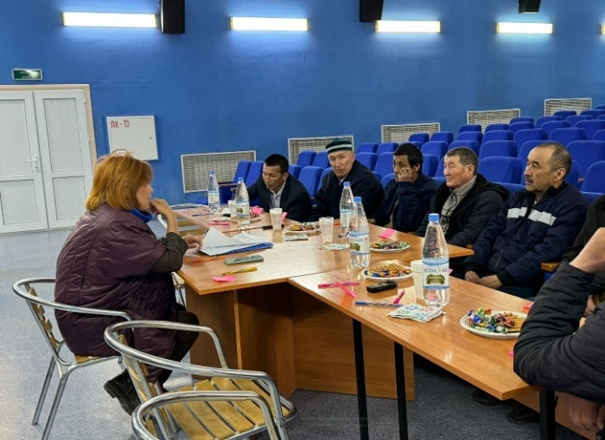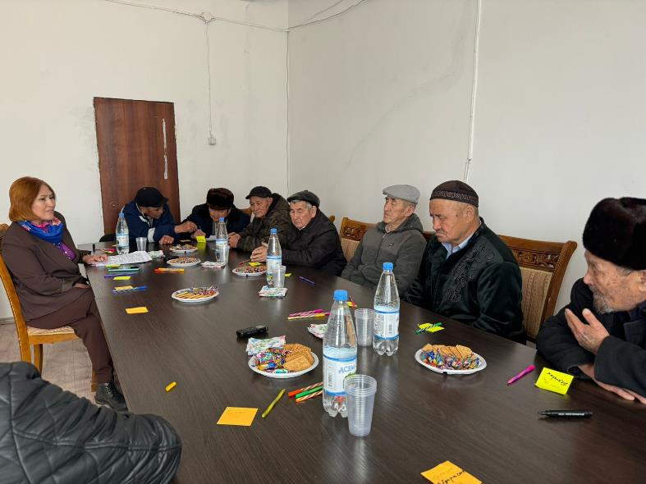
Focus group in Taikonyr village (left) and Kyzemshek village (right)

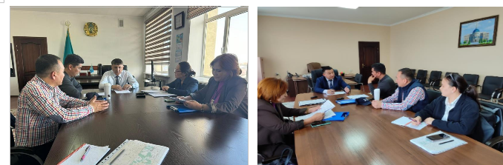
Meeting and interview with O.M. Zhamiyev, Chairman of the Maslikhat of the Sozak region, and A.B. Satybaldy, Deputy Akim of the Sozak district, Sholakkorgan village

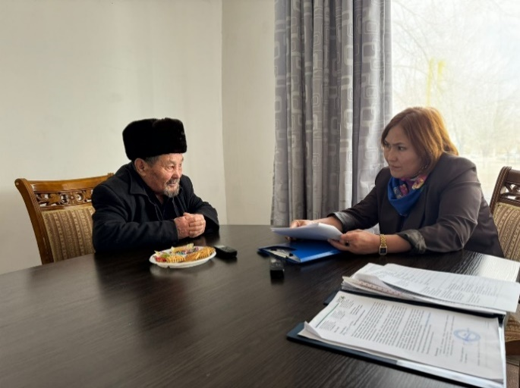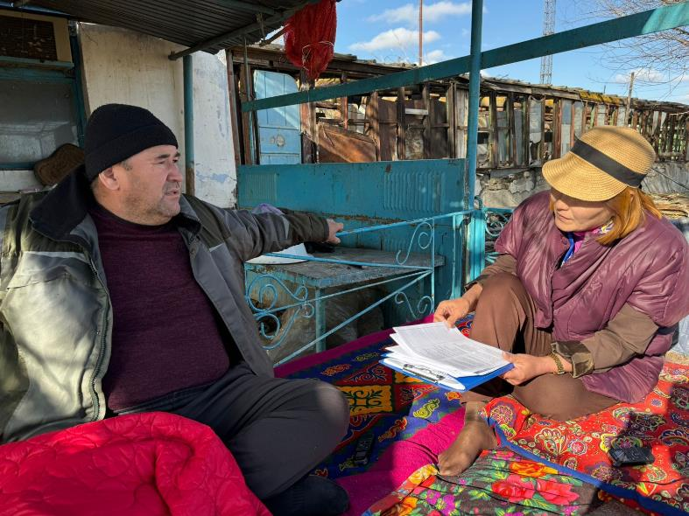
Meeting and interview with land user Pernebay Otzhanuly and land user Bokanov Yerdos, Kyzemshek village

General assessment of the living conditions of the local population
№ | Rural locality | Employment rate | Unemployment rate | Income level of the population | Agricultural Development | Healthcare | Education | Water supply | Power supply | Roads and Traffic Safety | Development of Private Business | Socially Vulnerable Groups
1 | Kyzemshek village
2 | Taikonyr village

Symbols:
The color designation of the score | Evaluation value | Decoding
 | Very good | This area is well developed and quite satisfied with the residents.
 | Good | The sphere is sufficiently developed and suits the residents.
 | The average level | The state of this sphere is at a satisfactory level, there are some disadvantages
 | Unsatisfactory | The unsatisfactory state of this area, a large number of shortcomings
 | Very bad | The condition of this area is very bad, residents express obvious dissatisfaction.

The most problematic issues are unemployment, health care, and socially vulnerable groups. The issue of water supply and water quality also attracts a lot of attention from residents. The importance of this area is also determined by its impact on the health of residents and the potential for agricultural development, which, in turn, serves as one of the formative factors for employment and income levels.

«JV «SMCC» LLP has developed a Plan for interaction with stakeholders, including the local population. The plan provides for providing environmental information to the public, visiting farms, holding consultations, public hearings and other events.

On the Internet resource there is a page of "JV "SMCC" LLP https://ughk.kazatomprom.kz/ru. This page was created to submit a letter of appeal, and there are also hotline telephones. «NAC «Kazatomprom» JSC strictly controls all appeals and decisions made on them.

A responsible employee for interaction with the public from «JV «SMCC» LLP has been appointed in the Partnership:

Deputy Head of the Legal Department
Syzdyk Akhad Sagyndykuly

Email address: a.syzdyk@ughk.kazatomprom.kz

Phone: +7/7252/99-73-93 internal number. 45828

Shymkent, Al-Farabi district,
D. Kunaev Avenue, building 23A, index 160019

You can submit your requests and suggestions to the above contacts!

