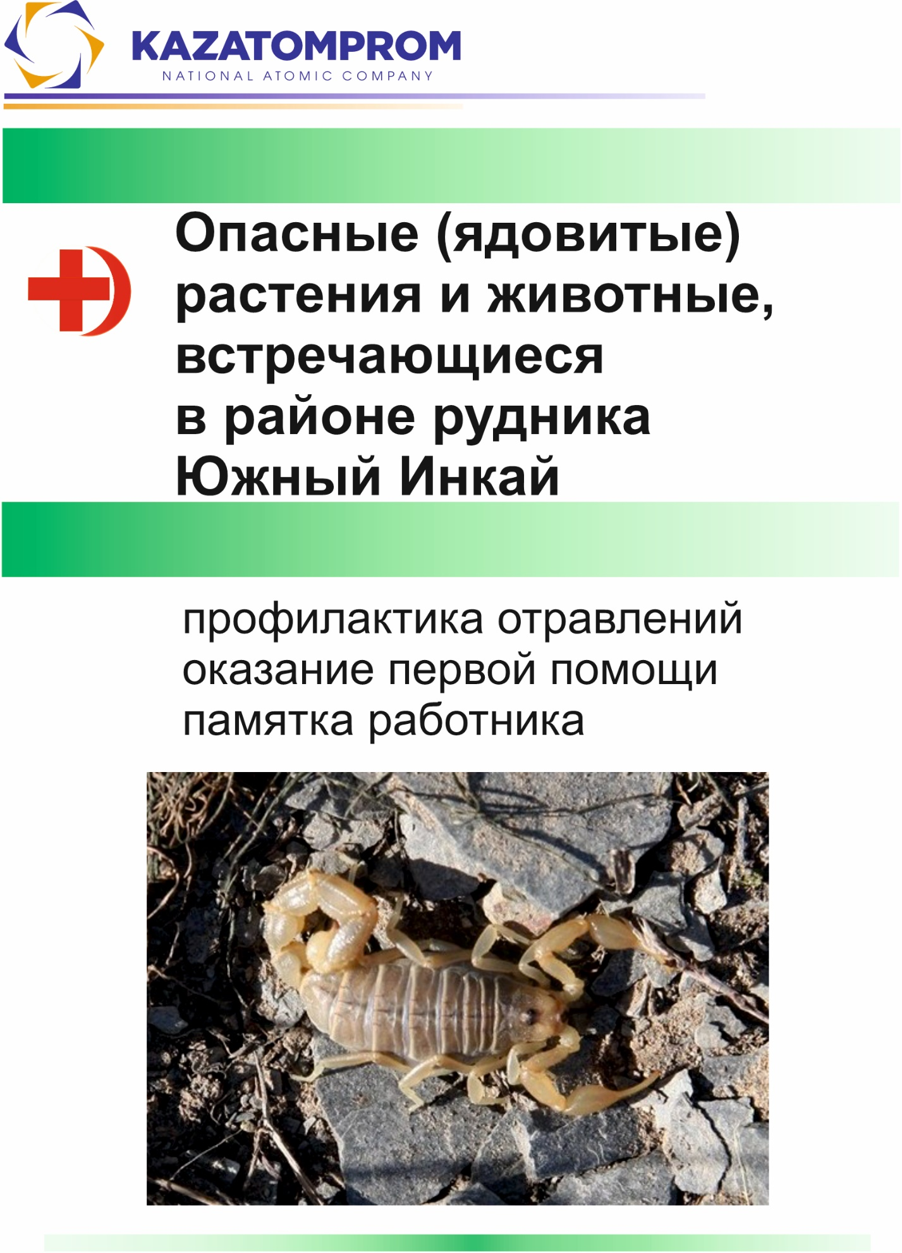

**Dangerous (Poisonous) Plants and Animals Found in the Area of the Yuzhny Inkai Mine.**

Poisoning prevention and first aid  
employee guideline

**«NAC «Kazatomprom» JSC**

**«Joint Venture «South Mining Chemical Company» LLP**

**«Institute of High Technologies» LLP**

**Center for Environmental Design and Monitoring**

**Dangerous (Poisonous) Plants and Animals Found in the Area of the Yuzhny Inkai Mine.**

Poisoning prevention and first aid  
employee guideline

**Almaty 2024**

INTRODUCTION

Poisonous animals and plants — which pose a real danger to humans and domestic animals — despite their negative impact on the national economy, are just as integral a part of ecosystems and the biosphere as all other living organisms. For example, venomous snakes help regulate the populations of rodents, which are agricultural pests and carriers of dangerous diseases, including various forms of plague. Among poisonous plants, many are also medicinal. Therefore, the task is to conserve, study, and use poisonous plants and animals in a rational way, within the framework of preserving biological diversity and ecosystems. Among poisonous plants and animals, there are many rare and endangered species listed in the Red Book and under protection.

DANGEROUS MICROORGANISMS

The smaller a living organism is, the more dangerous it can be. No matter how terrifying certain predatory animals may appear, statistically, far fewer people die from their attacks than, for example, from insect stings: bees, hornets, arachnids, etc. However, viruses and bacteria are undoubtedly the leading causes of death.

While attacks by predatory animals worldwide result in the deaths of dozens or hundreds of people, and snake bites cause tens of thousands of deaths, bee stings alone claim 3–4 times more lives than snake bites. But the highest number of fatalities is caused by infectious diseases: in some cases, the toll reaches hundreds of thousands or even millions of lives.

**Microorganisms: viruses, bacteria, and their carriers.**

Microorganisms such as viruses and bacteria have a relatively simple genome, which ultimately contributes to their rapid transformation, changes in properties, and the emergence of new types of diseases, some of which pose serious threats to life and health.

Rodents are carriers of dangerous infectious diseases. In Southern Kazakhstan, there are natural plague foci where rodents act as hosts of this dangerous infection, and their ectoparasites—fleas and ticks—serve as vectors of the plague bacterium (the most dangerous form of plague is pneumonic, which is transmitted through airborne droplets). Therefore, an increase in rodent population density in anthropogenic landscapes leads to a higher risk of infection for workers and local residents.

Moreover, fleas and ticks found on rodents transmit various infectious diseases typical for their host animals. In addition, wild animals may carry other dangerous infections—rabies, tularemia, Crimean-Congo hemorrhagic fever, Q fever, and others.

|  |  |
| --- | --- |
|  |  |
| Yellow Ground Squirrel (Photo by D.G. Faleev, EDMC) | Great Gerbil |

In nature, it is strongly advised not only to avoid contact with rodents but also to refrain from visiting or digging up their burrows, even if they appear abandoned. This is because ticks and fleas – carriers of dangerous diseases – may still remain in these burrows.

**The simplest and most effective recommendations for the prevention of various infectious diseases of bacterial and viral origin:**

***\* strengthening the immune system:***

– a healthy lifestyle – without bad habits, avoiding smoking, alcohol consumption, and the like,  
– regular physical activity (walking, running, sports games, etc.),  
– adherence to work and rest schedules,  
– healthy and timely nutrition,  
– hardening procedures (washing or pouring cold water),  
– outdoor walks and sports activities,

***\* observing hygiene standards:***

– hands should be washed after using the toilet, before eating, and after being outside,  
– timely changing and washing of clothes, including special (protective) clothing,  
– preventing the entry of animals – carriers of dangerous infectious diseases – such as flies, rodents (mice, rats), birds, etc., into living spaces or food facilities, and ensuring the proper isolation and disposal of household waste, especially food waste,  
– use only boiled water when outdoors,  
– proper thermal processing of food, and appropriate storage of food products,  
– thorough washing of fruits with clean water before consumption, preferably with baking soda or by scalding with boiling water,  
– timely identification and provision of qualified medical assistance in case of disease detection among mine personnel; if necessary, implement quarantine measures through the isolation of the infected individual(s).

**Toxins – Allergens**

A significant number of toxins found in nature act as allergens for humans. The ability to tolerate the effects of various toxins depends on numerous factors:

– location of the bites – the most dangerous are bites to the head, tongue, neck, and face; and the number of bites – multiple bites are particularly dangerous,  
– age (children and the elderly are more vulnerable),  
– general state of health and immune system,  
– presence of chronic illnesses – neurotoxins target damaged organs (for example, in the presence of a neurotoxic venom, heart disease becomes an aggravating factor, increasing the risk of various complications, including complications of the heart condition up to a fatal outcome),  
– the psychological state of the victim (panic and fear worsen the overall condition during poisoning).

The simplest method of preventing or localizing (blocking) an allergic reaction to the venom of poisonous animals is the use of antihistamines: **diazoline, tavegil, suprastin, diphenhydramine.**

In more severe and rapidly developing allergic reactions (such as angioedema, when breathing becomes difficult or blocked), healthcare professionals administer **prednisolone intramuscularly** (IM) or intravenously (IV). The dosage is calculated based on the patient's body weight; overdose affects the adrenal glands, as prednisolone is similar to an adrenal hormone.

The most important characteristics of allergic reactions are the location of their manifestation and the timing of their development.

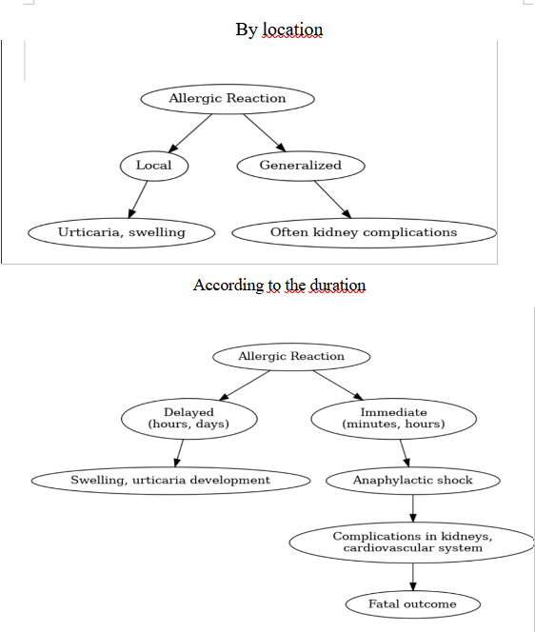

*Characteristics of Allergic Reactions*

**Poisonous Plants**

Poisoning by poisonous plants is most likely to occur in cases of overdose of medicinal drugs based on herbal plants.

First aid for food poisoning caused by poisonous plants includes:

– drinking plenty of fluids to accelerate the elimination of toxins from the body,  
– gastric lavage with a weak solution of potassium permanganate (0.1% solution of KMnO₄),  
– activated charcoal at a dosage of 1 tablet per 10 kg of body weight (or an aqueous suspension of activated charcoal: 2–3 tablespoons per 0.5 liters of water), with the tablets crushed or chewed beforehand.

In addition, poisoning of livestock is possible when poisonous plants get into the feed during harvesting or if the feed is improperly stored and consumed by the animals.

***Eastern Dodartia***

|  |  |
| --- | --- |
| Изображение особи Dodartia orientalis. | Изображение особи Dodartia orientalis. |

(photo from the website [https://www.plantarium.ru](https://www.plantarium.ru/))

It grows on rocky slopes and sandy soils, in saline and alkaline steppe meadows, along river valleys, in gardens, and by roadsides. It blooms from May to August. It bears fruit in August–September. A perennial herbaceous plant, whose roots, stems, leaves, and flowers are poisonous. It poses a danger only if ingested or when overdosed in decoctions and infusions. It is a valuable medicinal plant.

***Creeping knapweed, кекре (kekre)***

|  |  |
| --- | --- |
| Изображение особи Acroptilon repens. | Изображение особи Acroptilon repens. |

(photo from the website [https://www.plantarium.ru](https://www.plantarium.ru/))

It grows well on both light and heavy clay soils and tolerates saline soils. It infests crops of all types, as well as orchards, vineyards, meadows, and pastures; it also grows along roadsides and railway embankments. It blooms from April to June. Fruiting occurs from June to September. This is a herbaceous perennial plant with poisonous roots, stems, leaves, and flowers. It poses a danger only when consumed or in case of overdose in decoctions and infusions. It is considered a valuable medicinal plant.

***Cocklebur (Xanthium macrocarpum), ошаган (oshagan)***

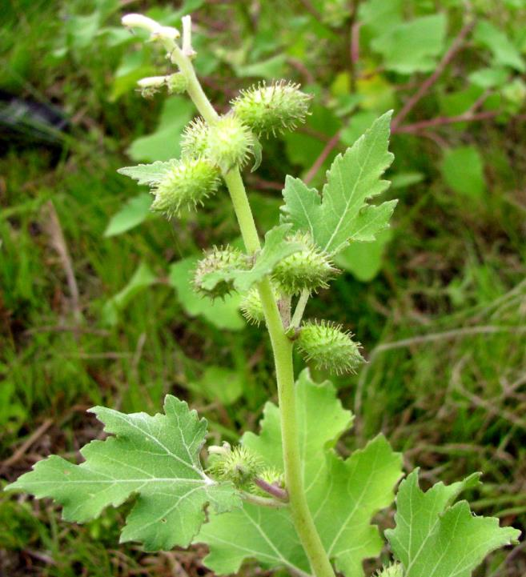

(photo from the website [https://www.plantarium.ru](https://www.plantarium.ru/))

Grows on moist sandy soils along riverbanks and ditches, near fences and roads, in wastelands, garbage dumps, and in cotton and other crop fields. Blooms from July to September, seeds ripen from September to October.

An annual herbaceous plant, with toxic roots, stems, and leaves. It poses a danger only when ingested or in case of overdose in decoctions and infusions. A valuable medicinal plant.

***Descurainia sophiae***

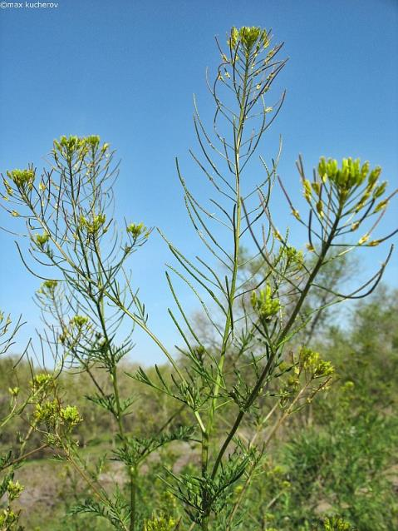

(photo from the website [https://www.plantarium.ru](https://www.plantarium.ru/))

It grows in pastures, gardens, along roads, in waste areas, near dwellings, in fields, meadows, and saline areas, and sometimes on hillsides and along riverbanks.

It blooms from May to August and bears fruit until September.

An annual herbaceous plant with poisonous roots, stems, leaves, and flowers. It poses a danger only when ingested or in case of overdose in decoctions and infusions. A valuable medicinal plant.

***Thick-fruited Goebelia, Sophora, Brunecz, Есек мия (Yesek Miya)***

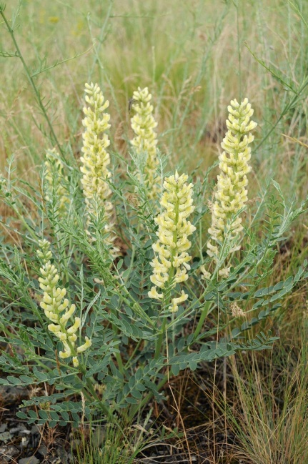

(photo from the website [https://www.plantarium.ru](https://www.plantarium.ru/))

It grows in saline meadows, rocky hills, river valleys and banks, and in crop fields. It blooms from May to June and bears fruit from June to August.

A perennial herbaceous plant, all parts of which are poisonous (roots, stems, leaves, flowers, seeds). It poses a danger only if ingested or in case of overdose in decoctions and infusions. A valuable medicinal plant.

***Belanger’s salt-plume (Salsola belangeriana), карабарак (karabarak)***

|  |  |
| --- | --- |
| Изображение особи Halostachys belangeriana. | Изображение особи Halostachys belangeriana. |

(photo from the website [https://www.plantarium.ru](https://www.plantarium.ru/))

Grows in salt marshes, salty ditches, dry riverbeds, and along the shores of salt lakes.

Flowering and fruiting occur from July to November.  
A shrub whose green parts are poisonous if ingested. At the same time, it serves as forage (during flowering) and has medicinal properties.

***Clasping pepperweed***

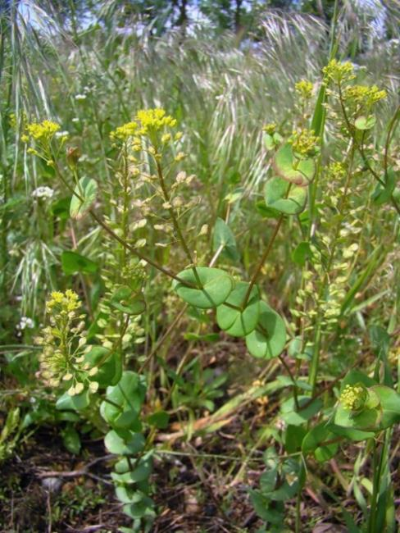

(photo from the website [https://www.plantarium.ru](https://www.plantarium.ru/))

It grows on dry steppe slopes, forest glades, meadows, along river valleys, at the edges of salt flats, in saline lowlands, along field and roadside edges, and in cultivated fields.

It blooms from April to July and bears fruit from May to August.

An annual or biennial herbaceous plant, whose stems, leaves, and flowers are poisonous. It poses a danger only if ingested or in cases of overdose in decoctions and infusions. A valuable medicinal plant.

***Leafless Sand Spurry***

|  |  |
| --- | --- |
| Изображение особи Anabasis aphylla. | Изображение особи Anabasis aphylla. |

(photo from the website [https://www.plantarium.ru](https://www.plantarium.ru/))

It grows on clayey saline soils of deserts and semi-deserts, on takyrs, sierozems, solonetzes, and less frequently on salt flats.

It flowers in July and bears fruit in August–September.

A subshrub with poisonous green non-woody parts. It poses a danger only when ingested or in cases of overdose of decoctions and infusions. A valuable medicinal plant.

***Sand Onion, Aрам жуа (Aram Jua)***

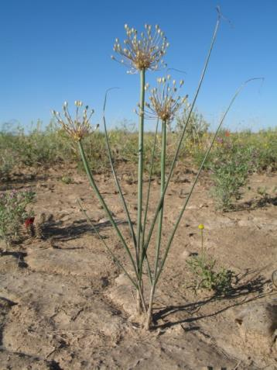

(photo from the website [https://www.plantarium.ru](https://www.plantarium.ru/))

Grows in sandy deserts. Blooms from May to June and bears fruit from June to July.  
A perennial herbaceous bulbous plant, all parts of which are poisonous. It poses a danger only when consumed in excessive amounts. It is a fodder, vitamin-rich, and ornamental plant.

***Syrian rue, адраспан (adraspán)***

|  |  |
| --- | --- |
| Изображение особи Peganum harmala. | Изображение особи Peganum harmala. |

(photo from the website [https://www.plantarium.ru](https://www.plantarium.ru/))

It grows on clayey, saline soils, sands, in semi-deserts and steppes, occupying desert pastures and rocky areas. It is often found as a weed in cereal and alfalfa fields, melon patches, vineyards, along roads, and on sandy shores of lakes and rivers. It blooms from May to July and bears fruit from July to August. A perennial herbaceous plant with a strong, specific odor, all parts of which are poisonous. It poses a danger when ingested or when decoctions and infusions are overdosed. It is a valuable medicinal and dye plant.

***Straight-horned Calotropis Қаракыз (Karakyz)***

|  |  |
| --- | --- |
| Изображение особи Ceratocephala orthoceras. | Изображение особи Ceratocephala orthoceras. |

(photo from the website [https://www.plantarium.ru](https://www.plantarium.ru/))

It grows on sandy and clay soils of steppes and deserts, on abandoned pastures, screes, and gravelly areas. It blooms in April–May and bears fruit in May–June. This annual plant is highly poisonous in all its parts and is dangerous if ingested. For medicinal purposes, it is used only externally and with great caution.

***Peacock Poppy***

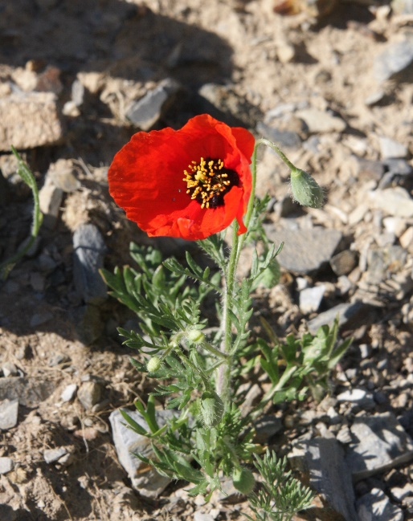

**Peacock Poppy** (Photo by D.G. Faleev, EDMC)

Widespread throughout Kazakhstan. Grows in clay deserts, on sands, and on rocky gravelly and clay slopes of the lower mountain belt. **Flowering:** April–July. **Fruiting:** May–August.

An annual herbaceous plant with poisonous stems and leaves. Poses a danger when ingested by humans or when a large amount of its milky sap comes into contact with the skin.  
Ornamental plant.

**POISONOUS ANIMALS**

Invertebrate Animals

**Arachnids**

All arachnids possess some of the most deadly types of venom in their arsenal. However, the danger largely depends on the venom delivery apparatus of each species. The vast majority of spiders are unable to pierce human skin with their chelicerae. The most dangerous are the karakurt spiders (black widows), and bites from tarantulas and scorpions can also cause significant effects.

***Scorpions***

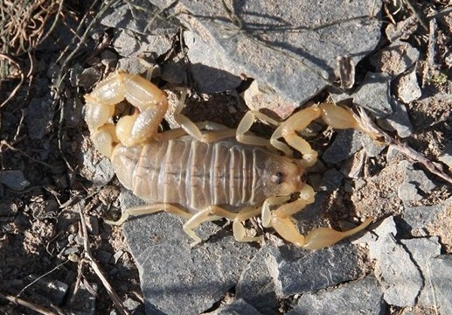

**Spotted Scorpion** (photo by D.G. Faleev, EDMC)

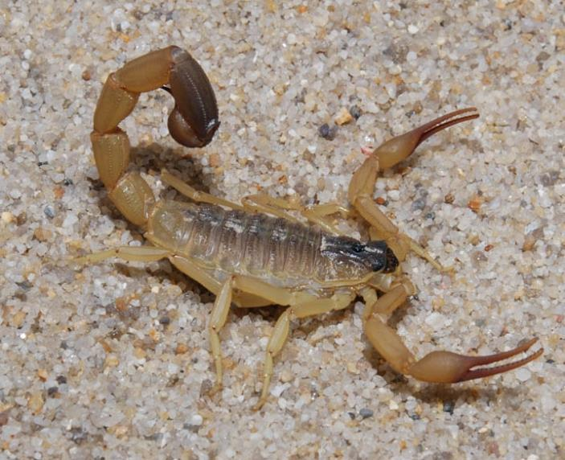

**Caucasian Scorpion**  
(photo taken from the website <https://www.terraforum.net/showthread.php?14-Mesobuthus-caucasicus>)

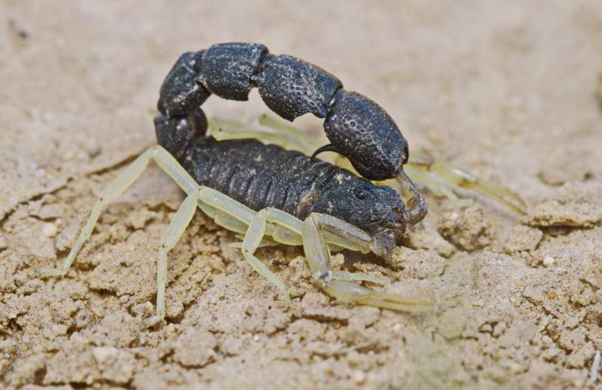

**Black Scorpion**  
(photo taken from the website <http://macroid.ru/showphoto.php?photo=157809>)

Several species of scorpions inhabit the area: the mottled scorpion, the Caucasian scorpion, and the black scorpion. The mottled and black scorpions are medium-sized, reaching 40–50 mm in length. The Caucasian scorpion is larger, growing up to 80 mm long. The most venomous species are the Caucasian and black scorpions. Their stings are not fatal but are extremely painful and often accompanied by headaches, nausea, and vomiting.  
****Habitat**:** they are commonly found in desert and semi-desert regions, especially in rocky and clayey areas.

**Camel Spider or Solifugae**

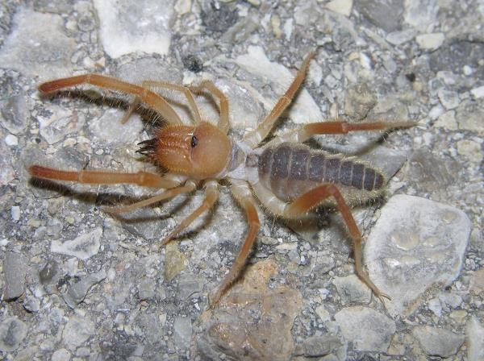

**Camel Spider** or **Solifugae**

(Photo taken from the website: <http://animalworld.com.ua/news/Falangi-ili-solpugi-ili-bihorki-ili-verbljuzhij-pauk-Solifugae>)

The body length of solifuges reaches up to 55 mm. Their coloration is typically sandy-yellow, often darker on the back. They are nocturnal and are often attracted to campfire or lamp light at night. Although not venomous, large individuals are capable of piercing human skin and causing bleeding. **Habitat:** They prefer clay deserts and are less commonly found on stabilized sands.

**Karakurt Spiders**

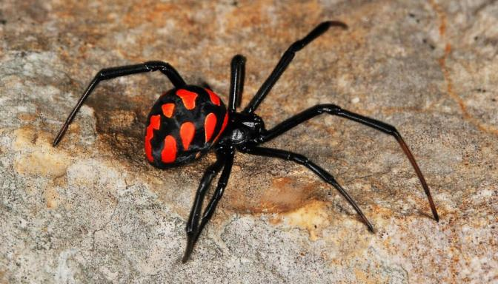

**Karakurt or Black Widow**  
(photo taken from the website tsentr-dezinsektsii.rf)

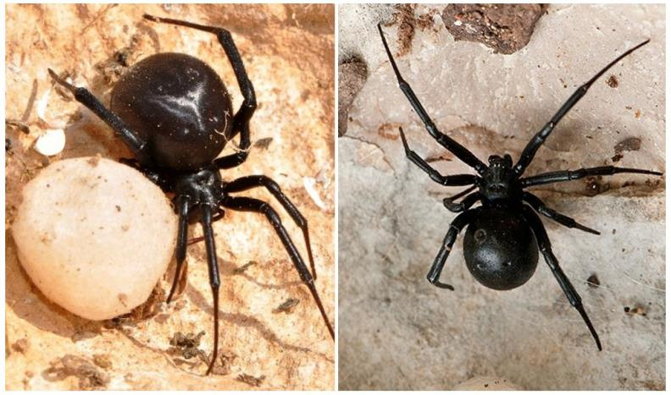

**Dahl's Karakurt**  
(photo taken from the website [*https://apest.ru/pauki/mesta-obitaniya/pauki-kazahstana/*](https://apest.ru/pauki/mesta-obitaniya/pauki-kazahstana/))

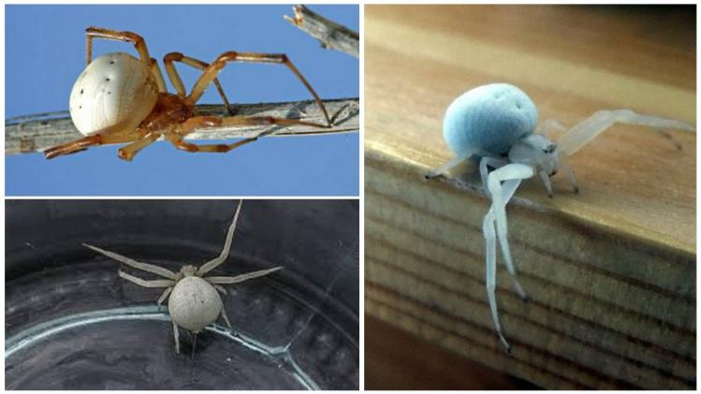

White Karakurt  
(photo taken from the website <https://apest.ru/pauki/mesta-obitaniya/pauki-kazahstana/>)

species occur in Kazakhstan: the black widow or karakurt, Dal’s karakurt, and the white karakurt. The most studied and dangerous is the karakurt, or black widow. The other species of the genus are less studied but are presumed to be equally venomous and dangerous.

The body length of adult male karakurts reaches 3–6 mm, females 9–17 mm. The body is black, with red spots on the abdomen, sometimes bordered with white around each spot. Mature individuals are sometimes entirely black without spots. Only the female karakurt is dangerous; the female black widow is characterized by a velvety black color. It is found in desert and steppe areas, foothills, inhabiting bushes, ravines, rocky places, and cliffs.

The female lives in a nest made of tangled plants and spider webs, less commonly in rodent burrows or other suitable places. Near humans, karakurts prefer to settle in abandoned or rarely used buildings such as sheds, garages, toilets, old barns, etc. The white karakurt builds a nest shaped like a hollow cone connected to a capture web by long signal threads.

The venom is highly toxic; there are known cases of death among humans and farm animals. A specific anti-karakurt antivenom is used to treat bites. However, it requires special storage conditions — low and stable temperatures. Therefore, this antivenom is unlikely to be available in medical facilities, especially in rural areas. Consequently, immediate first aid must be administered by those nearby without delay.

Karakurt venom is neurotoxic — it affects the peripheral and central nervous systems (CNS), and the bite is very painful.

**First aid must be administered within the first few minutes after the bite — no later than 15 minutes.**  “Already 15–30 minutes after the bite, the pain spreads throughout the body. Patients usually complain of unbearable pain in the abdomen, lower back, and chest. A characteristic symptom is severe tension of the abdominal muscles.

General poisoning symptoms include shortness of breath, heart palpitations, increased pulse rate, dizziness, headache, tremors, vomiting, pallor or facial flushing, sweating, and a feeling of heaviness in the chest and epigastric regions. Other typical symptoms are priapism, bronchospasm, and retention of urine and feces. Psychomotor agitation in the late stages of poisoning is replaced by deep depression, clouding of consciousness, and delirium. Fatal cases have been reported in both humans and livestock” (Orlov B.N. et al., 1990).

Black widow spider bites are especially dangerous for children: due to their smaller body mass, the concentration of venom per unit of body weight is higher compared to adults, and their nervous system is still immature (Schwann cell sheaths of nerve cells are not fully developed). All these factors make a child’s body more vulnerable to the black widow’s venom. Consequently, the risk of severe, even fatal, consequences from a bite is significantly higher in children than in adults.

In the event of a black widow bite, the bite site should be cauterized within 2–3 minutes using the head of a lit match. The venom is destroyed at a temperature of +70 °C. The spider’s chelicerae can pierce the skin to a depth of up to 0.5 mm, while the skin thickness is about 1.5 mm, which makes cauterization highly effective.

Natural enemies of the black widow in the wild include wasps, parasitic wasps, hedgehogs, as well as sheep, whose flocks trample spiders and their egg sacs. Due to heavy grazing pressure on ecosystems and frequent overgrazing, black widow populations are generally low.

**Tarantula**

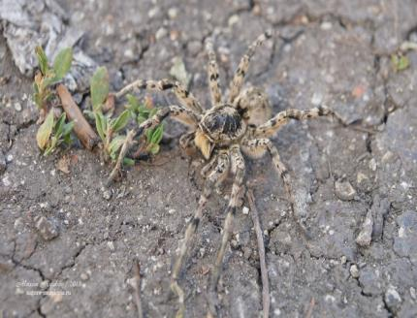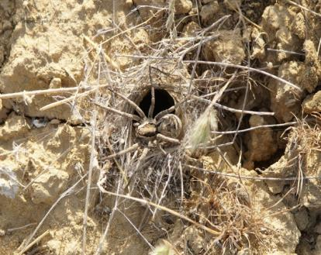

Tarantula

(Photo taken from the website <https://maxim-ryzhov.livejournal.com/182146.html>)

The body length of adult females can exceed 30 mm, while males are noticeably smaller. The body coloration is reddish-brown on the upper side and dark, almost black, on the underside. It is active at night. The bite is painful but not life-threatening. Habitat: Prefers dry climates and is found in deserts, semi-deserts, as well as in steppes and forest-steppes. It mainly inhabits areas with soft soil, often near human dwellings.

**Preventive Measures Against Spider and Scorpion Bites:**

– Wear thick clothing and closed footwear, preferably with high tops; special protective clothing and shoes are highly recommended.  
– In field conditions, ensure sleeping areas are tightly sealed to prevent arthropods from entering tents or sleeping bags; use mosquito netting if available.  
– Arachnids often crawl into shoes and may bite when the shoes are put on. To prevent such bites, carefully inspect footwear before use. A small piece of cloth slightly moistened with diesel fuel can be placed inside shoes to deter arachnids.

**Vertebrate Animals**

**Green Toad**

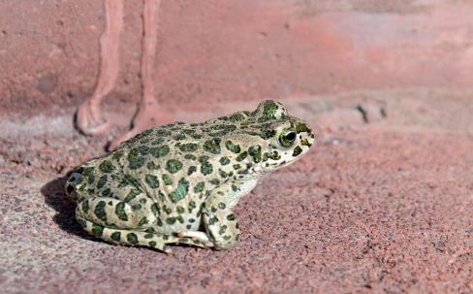

**Green Toad**

(Photo taken from the website [https://reptilia.club](https://reptilia.club/). Photo by Leonid Ishkov)

A medium-sized toad, with a body length of up to 120–140 mm. Its upper body is colored olive or grayish-green with large green spots. The skin is covered with small bumps, and two poison glands are located behind the eyes. The toxin can cause irritation if it comes into contact with mucous membranes, but it is not life-threatening to humans. The green toad is not aggressive and will usually try to escape when encountering a person. There is no need to catch or kill the toad—simply walk around it. In nature, toads are beneficial as they help regulate the number of harmful insects—carriers of dangerous diseases (flies, mosquitoes, ticks).

**Habitat**: Adapted to life in mountainous and desert environments. It lives in moist highlands, rocky lowland gorges, and desert zones, usually staying close to water sources.

**Venomous Snakes**

The vast majority of snakes (80–90%) are not dangerous to humans—for example, the grass snake, patterned racer, sand boa, and others. The glass lizard (also known as sheltopusik) is not even a snake, but a legless lizard. The arrow snake is venomous, but its bite poses no danger to humans due to the structure of its venom delivery system—the venomous fangs are located deep in the throat.

The most commonly encountered venomous snakes are the viper and the pit viper. Characteristic features of venomous snakes include a distinctly triangular head, a thicker and broader body, and vertical pupils.

***On First Aid for Snakebites***

The claim that sucking out snake venom is dangerous due to the possible presence of micro-cracks, wounds, or cavities in the mouth is highly debatable. The body’s natural defense mechanisms are designed to cleanse wounds by causing fluid to flow outward or at least to block foreign substances from entering the body—rather than absorbing them. In fact, up to 40% of the venom can be removed from the wound by suction. Some numbness in the mouth may occur as a result of the venom’s effects.

A good remedy for neutralizing snake venom is antivenom. However, antivenom requires special storage conditions, including consistently low temperatures, which makes storage and use difficult—especially in rural medical facilities where it is unlikely to be available. Therefore, one should not rely on antivenom and instead promptly begin first aid using available resources. Proper, timely, and quick first aid in the event of a venomous snakebite significantly increases the chances of a favorable outcome.

**First Aid for Venomous Snake Bites**

– The victim should be laid down in the shade with their head positioned lower than the body to reduce the risk of cerebral circulation disorders.  
– Immediately begin suction of the venom from the wound. Vigorous early suction for 5–7 minutes can remove up to 40% of the venom; however, after 15–30 minutes, only about 10% can be removed. If the bite is on the arm, the victim may perform suction on their own.  
– In any case, the extracted fluid must be spat out. After suction, the mouth should be rinsed with a potassium permanganate solution or clean water.  
– During suction, it is advisable to gently massage the area around the bite in the direction of the wound openings.  
– In the first few minutes after the bite, venom removal can be improved by opening the wound. Use a sterile needle from a syringe or a sewing needle, sterilized beforehand with alcohol (vodka), a lit match, or a lighter. Insert the needle into the wound (no deeper than 4 mm) and slightly tear the edges of the wound in the direction toward the lower jaw (relative to the snake's bite). This is important because venom is typically concentrated in the deeper tissues. After the wound is opened, the venom is expelled more effectively with the flow of blood and lymph.  
– At the first signs of swelling, suction should be stopped. Treat the bite site with antiseptics and apply a tight sterile dressing. It is crucial to immobilize the affected limb completely (with a splint, for example) to reduce the spread of venom through the lymphatic system.  
– Applying a tourniquet is strictly contraindicated.  
– Do not cauterize the wound, as the venom is located quite deep (up to 5 mm) and will not be destroyed by heat. Cauterization may seal the wound’s surface, block bleeding, and prevent the venom from draining out.

– It is essential to ensure the victim remains completely at rest.  
– Provide plenty of fluids (strong tea or coffee can act as stimulants for blood circulation and the body’s defense mechanisms) to help speed up venom elimination and restore the body’s water-salt balance, especially in hot weather.  
– The use of alcoholic beverages will only worsen the severity of the poisoning. Alcohol is an additional toxin; in large quantities, it suppresses blood circulation, metabolism, and the immune response.  
– Most importantly, the victim must be transported to a medical facility as quickly as possible to receive professional medical assistance.

***What to do if you’ve been bitten by a snake and no help is available:***

– Perform all procedures for providing first aid.  
– Prepare at least 10–15 liters of water nearby. It is better to use herbal diuretic teas (raspberry leaf, blackcurrant leaf, field horsetail, knotweed) and/or eat watermelon or melon.  
– Immediately take any available antihistamines (Diazolin, Tavegil, Suprastin, Diphenhydramine).  
– Set up a resting place for yourself (for about 24 hours) in case of temporary immobility or vision loss.  
– In most cases, people bitten by venomous snakes die not from the venom, but from fear and panic — for example, by falling into pits, off cliffs, etc.

**Snakebite Prevention:**

– Avoid handling snakes unless absolutely necessary.  
– Wear thick, loose-fitting, long clothing and closed (high) footwear. Specialized clothing and footwear that minimize exposed skin are ideal.  
– When camping, make sure sleeping areas are tightly sealed to prevent snakes from entering tents or sleeping bags. Use mosquito nets where possible.  
– At night, always use a flashlight in the dark, especially in warm weather, as snakes often come out to warm themselves on open paths or roads.  
– Be cautious when moving through dense vegetation, rocky areas, uneven terrain, or abandoned buildings (such as sheds, barns, garages, etc.).  
– If you’re unsure whether a snake may be present, use a stick to probe vegetation or potential snake shelters and make noise to scare the snake away.  
– In the wild, always inspect your shoes, bedding, and clothing before use to ensure there are no snakes inside.  
– If a snake enters a room, tent, or bed while you’re sleeping, stay calm. Avoid sudden movements that could provoke a bite. Wait for the snake to leave on its own or call for help. If it’s safe to do so, carefully push the snake away (e.g., if it’s on a blanket or sleeping bag).  
– Mice and rats attract snakes as prey. To avoid attracting snakes, control rodents and keep the area free of garbage and clutter.  
– Do not allow children to catch or kill snakes.

****Halys Pit Viper****

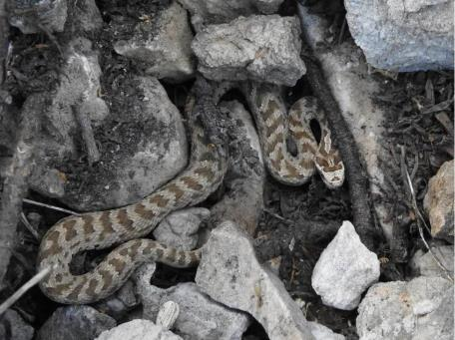

**Halys Pit Viper (Gloydius halys)**  
(Photo taken from the website [*https://reptilia.club*](https://reptilia.club/). Author: Georgiy Shakula)

This is a medium-sized snake, with a body length of about 70 cm and a tail length of approximately 10 cm. Its coloration varies from brownish-buff to yellowish-gray in individuals inhabiting steppe regions. The dorsal side typically features dark transverse bands, though these may be indistinct in some specimens, and small dark spots are present along the sides. The ventral side is light, usually with small dark speckles. Some individuals may be uniformly brick-red or nearly black.

The head is broad, with a well-defined neck constriction and is covered above with large scales forming a shield-like pattern. A distinct spotted pattern can be seen on the head, along with a dark stripe on each side. This species is venomous, and although fatalities are rare, isolated cases of human death from bites have been recorded.

When encountering a human, it usually attempts to flee. However, if escape is not possible, it may defend itself. In nature, the Halys pit viper is beneficial, helping control populations of insects and rodents that transmit dangerous diseases (such as gerbils and ground squirrels).

It is most numerous in mountains and foothills, often found in rocky areas and rodent colonies, but it also occurs in steppes and semi-deserts.

[**Arrow Snake**](http://www.snakes-kazakhstan.idhost.kz/Psammophis_lineolatus.html)

|  |  |
| --- | --- |
|  |  |

**Arrow Snake**  
(Photo taken from the website [*https://reptilia.club*](https://reptilia.club/), author: Georgy Shakula)

The dorsal coloration of the body ranges from gray, brownish-gray, and olive-gray to sandy tones. Four dark longitudinal stripes run along the back, although they may be faint or absent. The snout tip is rounded, and the pupil is round. It is venomous, but its bite is not dangerous to humans. When encountering a person, it usually tries to escape quickly. It prefers open arid areas and deserts. It is active during the daytime.

CONCLUSIONS

Humans are an integral part of nature. Living in harmony with the surrounding environment and learning to use its resources wisely is one of the most important challenges facing humanity today.

In this regard, acquiring knowledge about dangerous living organisms — their nature, properties, biology, and ecology — as well as developing the ability to prevent their harmful impact on humans and the national economy, is a key objective for various specialists, particularly for employees of «NAC «Kazatomprom» JSC.

At the same time, the conservation of potentially dangerous (venomous) animals and plants within the framework of environmental protection activities remains a pressing issue. Many poisonous plants and animals that pose potential threats to humans and domestic animals are rare and endangered species listed in the Red Book of Kazakhstan.

It is important to note that many potentially dangerous and venomous plants and animals have great potential for use in medicine, agriculture, environmental biotechnology, and other fields. Fully unlocking the immense potential of this group of living organisms requires careful treatment, comprehensive scientific research, and a rational approach to their use for the benefit of humanity.

Reference

Orlov B.N., Gelashvili D.B., Ibragimov A.K. Yadovitye zhivotnye i rasteniya SSSR [Poisonous Animals and Plants of the USSR]. – Moscow: Vysshaya shkola, 1990. – 272 p.

Volovich V.G. Chelovek v ekstremalnykh usloviyakh prirodnoy sredy [Man in Extreme Natural Conditions]. – Moscow: Mysl, 1980. – 190 p.

Ilichev A.A. Bolʹshaya entsiklopediya vyzhivaniya v ekstremalʹnykh situatsiyakh [The Great Encyclopedia of Survival in Extreme Situations]. – Moscow: Eksmo-Press, 2002. – 491 p.

Karpovich V.N., Bespalova E.I. Farmakognoziya [Pharmacognosy]. – Moscow: Meditsina, 1976. – 448 p

Kazenas V.L., Gromov A.V. Mir bespozvonochnykh zhivotnykh. Opasnye bespozvonochnye Kazakhstana [The World of Invertebrate Animals. Dangerous Invertebrates of Kazakhstan]. – Almaty: Kitap, 2007. – 128 p.

Zhiznʹ zhivotnykh [The Life of Animals] / Ed. by V.E. Sokolov. – Moscow: Prosveshchenie, 1984. – Vol. 3: Chlenistonogie: trilobity, khelitserovye, trakheynodyshashchie. Onikhofory [Arthropods: Trilobites, Chelicerates, Tracheates. Onychophores] / Ed. by M.S. Gilyarov, F.N. Pravdin. – 463 p.

*Scientific and Methodological Publication*

**Reviewer**: Candidate of Medical Sciences S. L. Dimitrienko.

Fadeev, D. G., Agapov, O. A., Fedorina, O. A., Panova, E. N. (2024). Dangerous (poisonous) plants and animals found in the area of the Yuzhny Inkai mine: Poisoning prevention, first aid. employee's safety guideline. Almaty: «IVT» LLP, Environmental Design and Monitoring Center (EDMC).